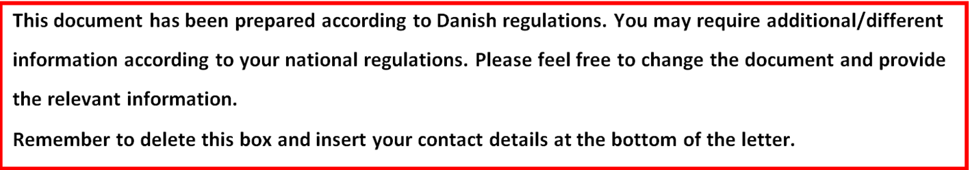
Information about participation in a scientific study of critically ill patients admitted to the intensive care unit.
You have been seriously ill and were in need of immediate treatment in the intensive care unit. You have participated in a medical research project. Because of your condition, we were not able to inform you and ask you directly if you wanted to participate in the study.
Now that you are improving, we will ask you if you want to continue participating in the study. You must fully understand what the study is about, and why we are conducting it. We kindly ask you to read the information below carefully.
You will be offered to talk with a person from the research group, where you will be given a more in depth understanding of the study and you can ask questions. You are welcome to bring a family member, a friend or an acquaintance to this conversation.
If you decide to continue your participation in the study, we will ask you to sign the attached consent form. Remember that you have the opportunity to consider your decision before signing.
It is voluntary to participate in the study. You may at any time and without giving a reason, withdraw your consent. Participation in the study will not have any influence on your treatment in general.
Background
For years it has been known that critically ill patients admitted to the intensive care unit are at risk of developing delirium caused by critical illness. For pharmacological treatment of delirium antipsychotics, more specifically haloperidol, have been used.
In spite of the lack of evidence for haloperidol, widespread use for delirium is likely. It is unclear how many patients receive haloperidol or other pharmacological treatment for delirium and how and when it is given.
In recent years, It has been questioned whether the treatment has any effect on delirium or survival in critically ill patients. It is also questioned whether the treatment has any potentially serious adverse reactions.
It is therefore unclear whether the treatment with haloperidol overall benefit or harm patients in the intensive care unit, and a future study clarifying this is highly warranted.
To perform a trial clarifying benefit or harm of the treatment for delirium, we need more knowledge on current use of haloperidol in the ICU setting to better design such complex trial.
Purpose of the study
The purpose of this study is to assess how many patients receive haloperidol or other antipsychotics treatment for delirium.
Status
You were admitted to the intensive care unit and treatment was immediately initiated because your condition required it. In relation to the scientific study, data was obtained from your medical record and registered in an electronic database for further analysis. The treatment for your medical condition has not been changed.
The study duration is from admission to the intensive care unit until discharge from the intensive care unit.
Discontinuation of the trial
As a participant, you can at any time withdraw from the study without justification. Withdrawal will not affect your relationship with the doctors or nurses in the department or your treatment. You will continue to get the treatment that is standard for your medical condition.
Advantages of the trial
By participating in this study you can help us obtaining information on current use of haloperidol for delirium to critically ill patient.
Disadvantages of the trial
There is no disadvantage for you by participating in the study.
Privacy and confidentiality
All information will be treated confidentially. When reporting and results and publishing the results of the study you will remain anonymous. The research group has access to your entire medical record to ensure that the study is carried out as described in the protocol. From your medical records we will use information about past medical history, blood test results, medication, other treatments and events in the ICU. Anyone with access to your notes is subject to confidentiality.
Economy
The study is funded by Innovation Fund Denmark and is independent of the pharmaceutical industry.
Access to study results
When the study is completed we will determine rates of haloperiodol use, delirium and survival among participants. The results will be published in an international scientific journal and on the website of the study (www.cric.nu)
Contact
The duration of the study is estimated to be 3 month, and 1000 patients in Europe, Canada and Brazil will participate.
We hope that you with this information feel sufficient informed and able to make a decision about your potential participation. For further information please feel free to contact one of the investigators below.
Yours Sincerely,
Local Principal Investigator:
NAME AND TITLE:
DEPARTMENT:
INSTITUTION:
WORKING ADRESS:
PHONE:
EMAIL:

NAME AND TITLE:
DEPARTMENT:
INSTITUTION:
WORKING ADRESS:
PHONE:
EMAIL:

