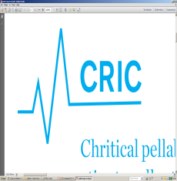

Invitation
to
All Stakeholders Meeting
________________________________________________
Date: April 26, 2019
Time: 10am-12am Lunch and network: Sandwich is served at 12am – 1pm
Place: Forskningsenheden, 2rd floor, Tagensvej 22, 2100 Copenhagen N (same building as usual but on the second floor)
Invited: CRIC Steering Committee members and other stakeholders of CRIC’s programs

Agenda
- Welcome (by Anders Perner)
- Presentation (all, short)
- Scientific challenges in CRIC programs presented by partners
  - SUP-ICU (Rigshospitalet)
  - AID-ICU (Køge)
  - HOT-ICU (Aalborg)
  - CLASSIC (Rigshospitalet)
  - Reviews (CTU)
  - Statistics (Bio KU)
  - Socio-economics (VIVE)
- Administrative challenges in CRIC office (by Maj-Brit Nørregaard Kjær)
- Network and lunch/sandwich
Please provide feedback to contact@cric.nu if you want to join the meeting.
The agenda is subject to changes on request by members.

