Pocket cards

On the next 2 pages, you will find the front and back page for the pocket cards to be used for screening in the COVID STEROID trial.

Instructions:
- Insert local hotline number (see yellow marking). Remove yellow marking after insertion of local hotline number.
- Print page 2 in colour print
- Cut out the front and back pages of each pocket card
- Laminate the pages with the back of each front and back page against one another
- Cut out

Inclusion criteria

- ≥ 18 years AND
- Confirmed SARS-CoV-2 AND
- One of the following:
- Invasive mechanical ventilation OR
- Non-invasive ventilation or continuous use of CPAP for hypoxia OR
- Oxygen supplementation with an oxygen flow ≥10 L/min irrespective of system used or the addition of atmospheric air

TURN

COVID-STEROID hotline:
+
covid-steroid@cric.nu
COVID-STEROID hotline:
+
covid-steroid@cric.nu

Inclusion criteria

- ≥ 18 years AND
- Confirmed SARS-CoV-2 AND
- One of the following:
- Invasive mechanical ventilation OR
- Non-invasive ventilation or continuous use of CPAP for hypoxia OR
- Oxygen supplementation with an oxygen flow ≥10 L/min irrespective of system used or the addition of atmospheric air

TURN
VEND

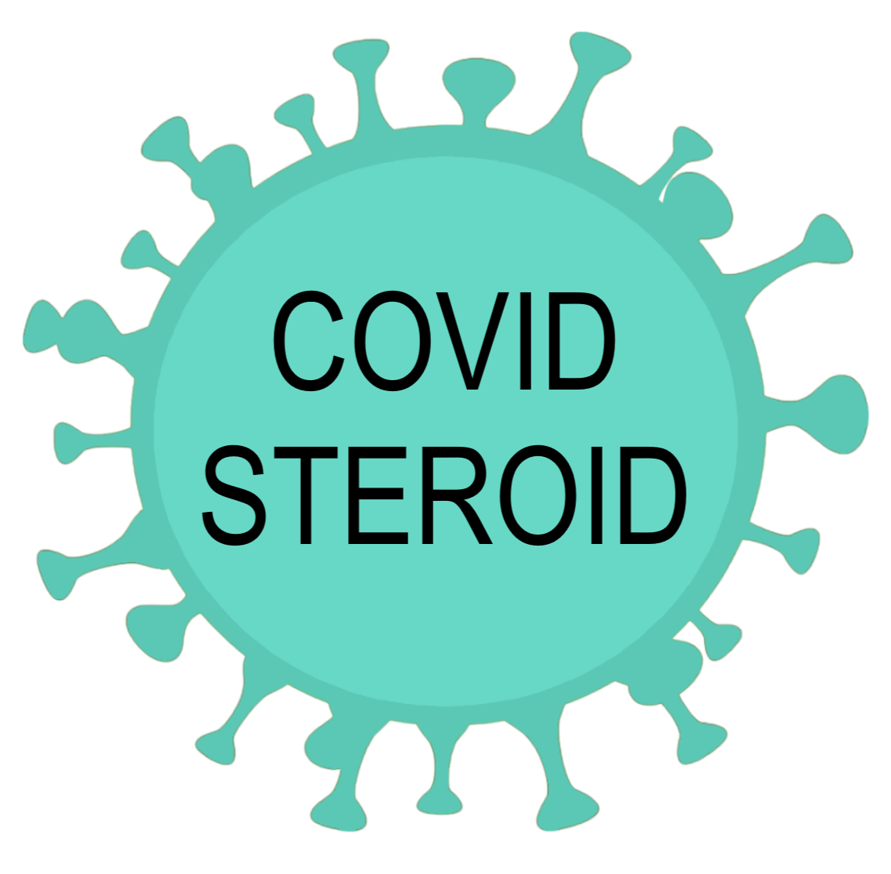

Low-dose hydrocortisone for patients with COVID-19 and severe hypoxia

Interventions

Trial medications
- Hydrocortisone 200 mg/day OR
- Isotonic saline (0.9%)
Preferably given as continuous infusion over 24 hours
- Total volume 104 ml
- Infusion rate 4.3 ml/hour

Alternatively given as bolus injections
- Bolus volume 10 ml
- Administered 4 times daily

COVID-STEROID hotline: +
TURN

Low-dose hydrocortisone for patients with COVID-19 and severe hypoxia

Interventions

Trial medications
- Hydrocortisone 200 mg/day OR
- Isotonic saline (0.9%)
Preferably given as continuous infusion over 24 hours
- Total volume 104 ml
- Infusion rate 4.3 ml/hour

Alternatively given as bolus injections
- Bolus volume 10 ml
- Administered 4 times daily

COVID-STEROID hotline: +
TURN

