Pocket cards

On the following two pages you will find front and back of a pocket card for clinicians screening and randomising patients in the HOT-ICU trial. There are two identical front pages and two identical back pages.

How to make the cards:
- Print the two pages
- Cut out the cards
- Laminate the pages back to back
- Cut out the cards (now laminated)
- Fold the cards over the middle

Inclusion criteria
Acute admission to the ICU
AND
Aged 18 years or above
AND
One of the following:
• Closed system
Closed system: Invasive mechanical ventilation, non-invasive ventilation (mask or helmet) or CPAP (mask or helmet)
• Open system with an oxygen flow ≥ 10 L/min
Includes high-flow systems (see conversion table on the back of this card if automatic mixers are used)
AND
Oxygen supplementation in the ICU, expected duration ≥ 24 hours
(If in doubt answer YES)
AND
Intra-arterial catheter in place

AND
COVID-19 positive (current admission)

Hotline: +45 2118 2543

Contact: hot-icu@cric.nu

9b_ Pocket_card_HOT-ICU_english_v1.0_02Jul2020

Inclusion criteria
Acute admission to the ICU
AND
Aged 18 years or above
AND
One of the following:
• Closed system
Closed system: Invasive mechanical ventilation, non-invasive ventilation (mask or helmet) or CPAP (mask or helmet)
• Open system with an oxygen flow ≥ 10 L/min
Includes high-flow systems (see conversion table on the back of this card if automatic mixers are used)
AND
Oxygen supplementation in the ICU, expected duration ≥ 24 hours
(If in doubt answer YES)
AND
Intra-arterial catheter in place

AND
COVID-19 positive (current admission)

Hotline: +45 2118 2543

Contact: hot-icu@cric.nu

9b_ Pocket_card_HOT-ICU_english_v1.0_02Jul2020

1. Check inclusion criteria:
See front page

2. Go to www.cric.nu/hot-covid
Follow the link (eCRF) and start screening
Check exclusion criteria during screening

3. Prior to randomisation:
- A negative pregnancy test (blood or urine) must be present in all women < 50 years of age

4. Follow procedure to randomise patient and to obtain allocated PaO₂ target

5. Adjust FiO₂ to achieve the allocated PaO₂ target of either:

8.0 kPa or 12.0 kPa

Your personal login:
User: Your e-mail
Password: Self-created. Can be reset at login-site

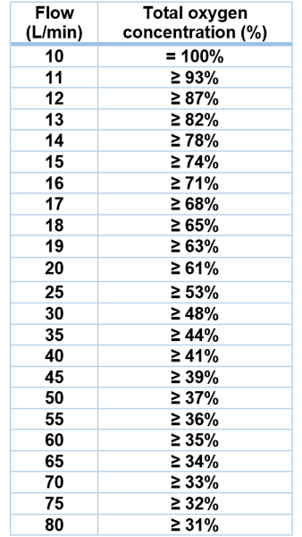
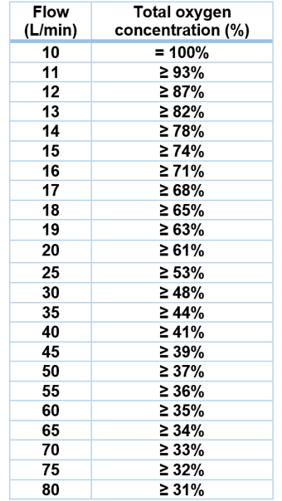

In open systems with automatic mixers (high-flow systems and certain humidifiers) or special gas mixtures (e.g. heliox) inclusion criteria of 10L/min of pure oxygen is fulfilled if the oxygen concentration exceeds the designated at specified flow rates:

1. Check inclusion criteria:
See front page

2. Go to www.cric.nu/hot-covid
Follow the link (eCRF) and start screening
Check exclusion criteria during screening

3. Prior to randomisation:
- A negative pregnancy test (blood or urine) must be present in all women < 50 years of age

4. Follow procedure to randomise patient and to obtain allocated PaO₂ target

5. Adjust FiO₂ to achieve the allocated PaO₂ target of either:

8.0 kPa or 12.0 kPa

Your personal login:
User: Your e-mail
Password: Self-created. Can be reset at login-site

In open systems with automatic mixers (high-flow systems and certain humidifiers) or special gas mixtures (e.g. heliox) inclusion criteria of 10L/min of pure oxygen is fulfilled if the oxygen concentration exceeds the designated at specified flow rates:

