9a_AID-ICU_SAR_SUSAR_v3_10dec2020

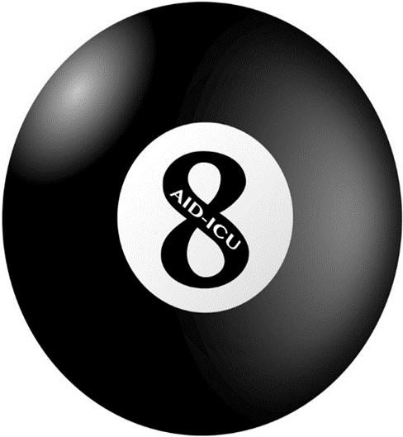
Place in Site Master File #9a

Instruction for the AID-ICU trial – serious adverse reactions (SARs) and suspected unexpected serious adverse reactions (SUSARs)

The treating clinician should be aware of the precautions and potential adverse reactions as listed in the Haloperidol product information (please see appendix 3 in the protocol). Patients should be monitored for known adverse reactions.
Because patients in the intensive care unit experience numerous serious adverse events (SAEs) the authorities have approved the position that SAEs do not have to be reported routinely in the AID-ICU trial. However, SARs and SUSARs will have to be registered and reported as described below.

Serious adverse reactions (SARs) and suspected unexpected serious adverse reactions (SUSARs) have to be reported to the coordinating centre within 24 hours.
By email: aid-icu@cric.nu
By phone: +45 9357 7750
Complete the SAR/SUSAR form in the eCRF at the website (www.cric.nu/aid-icu) and sent it by email to the coordinating centre. You will receive an email from the coordinating centre when the report has been registered.

Adverse reactions are listed in the summary of product characteristics (appendix 3 in the protocol).
An adverse reaction is considered serious (SAR) if it meets one or more of the following criteria:
- Results in death
- Is life-threatening
- Requires inpatient hospitalisation or prolongation of hospitalisation
- Results in persistent or significant disability/incapacity
- Is an important medical event which may require intervention to prevent one of the previously listed outcomes

Conditions considered as expected SARs are defined in appendix 2 in the protocol.
SARs will be reported daily in the eCRF.

A suspected unexpected serious adverse reaction (SUSAR) is defined as a serious adverse event whose nature, severity, specificity, or outcome is not consistent with a term or description in the product information.
If an adverse reaction is considered to be a SAR or a SUSAR and the situation allows it, please call the coordinating centre. The trial medication can be unblinded by:

- Calling the AID-ICU hotline (+45 9357 7750).Please refer to the identifier number at the vial
OR

All SARs and SUSARs will be monitored by the Data Monitoring and Safety Committee on a regular basis according to the protocol.
All SUSARs will be registered in the EudraVigilance database by the Danish authorities. Investigators at all participating sites will receive information by email if a SUSAR is reported and a yearly report of all registered SARs.
Please report SARs and/or SUSARs to your Ethics Committee as per local requirements

- Copies of any reporting and correspondence to and from your local ethic committee should be sent to the coordinating centre by email

