Instructions for GODIF trial – trial medication

This manual describes the use of the Medication Dispensing System and administration of the trial medication in the GODIF trial

Medication Dispensing System
At randomisation, the first trial medication vial will be allocated to the randomised patient. The identification number is printed on the label of the vial. The number will be sent to the email of the person who performed the randomisation. You can always find previously allocated vial identification numbers in the Medication Dispensing System, including the vial automatically dispensed at randomisation. When the first vial of trial medication is used, a new vial needs to be allocated to the patient. That is done in Medication Dispensing System. The frequency of dispensing trial medication is dependent of the patient’s need. When the vial with trial medicine is open, the medicine must be used within 24 hours.

1) Visit www.cric.nu/godif
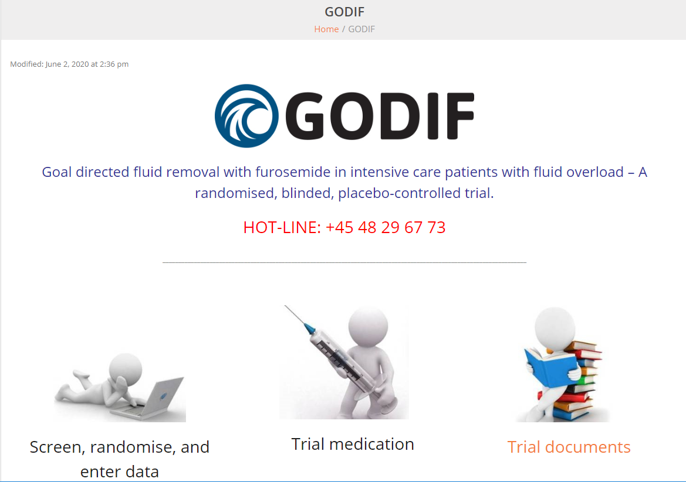

2) Click ’Trial medication’ to enter the medication module.

3) Log on with the shared login of your department

4) A list of enrolled patients at your department will appear

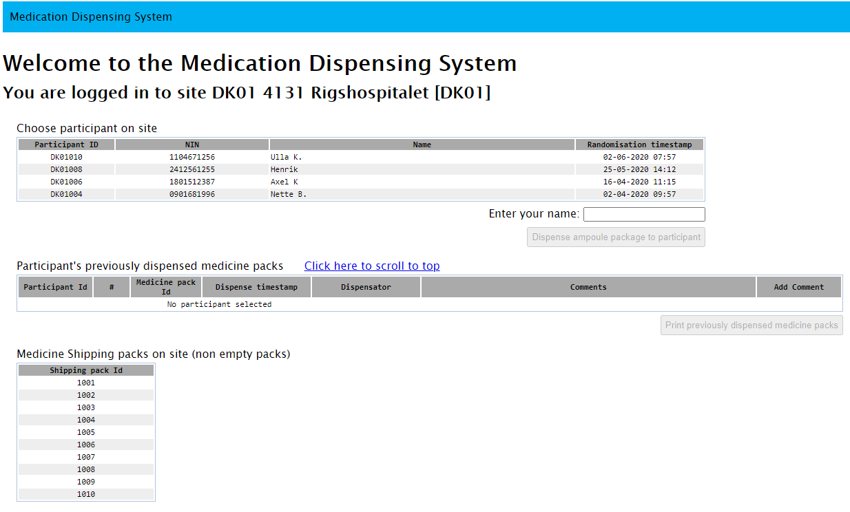

5) Mark the relevant patient in the list. A list of the identification numbers of previously dispensed packages to that patient will appear at the bottom of the page, including the automatically dispensed package from the time of randomisation.

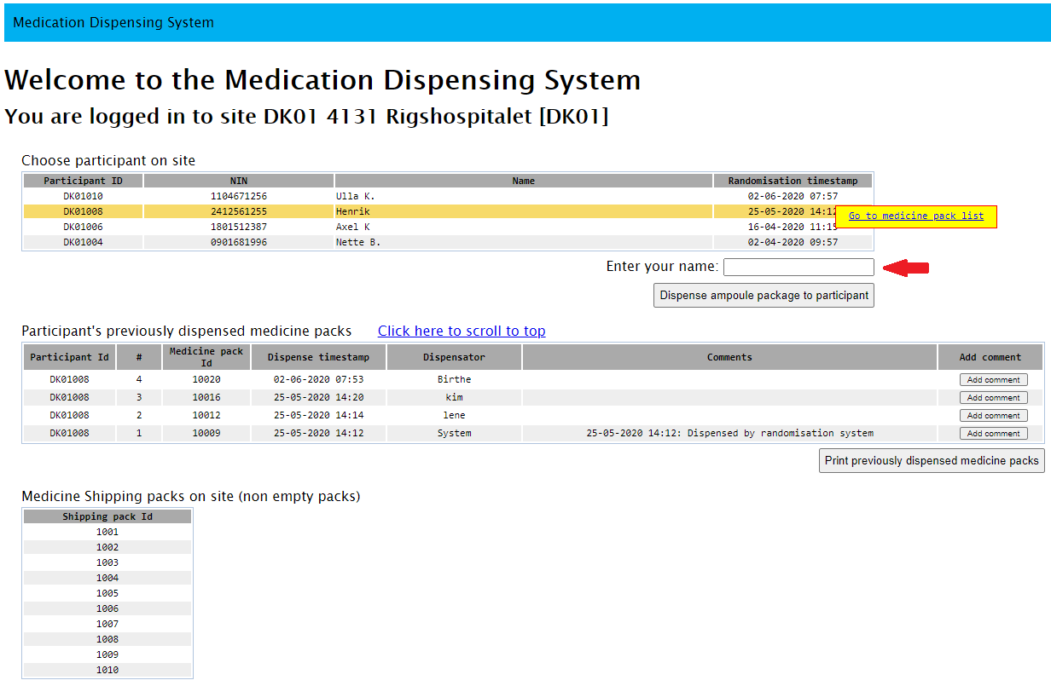

6) If you wish to dispense a vial of medicine to the selected patient, enter your name (red arrow) and press dispense ampoule package to participant.

7) You will be asked to confirm the dispensation of the trial medication. Please ensure that all data are correct before clicking ’Yes continue’.
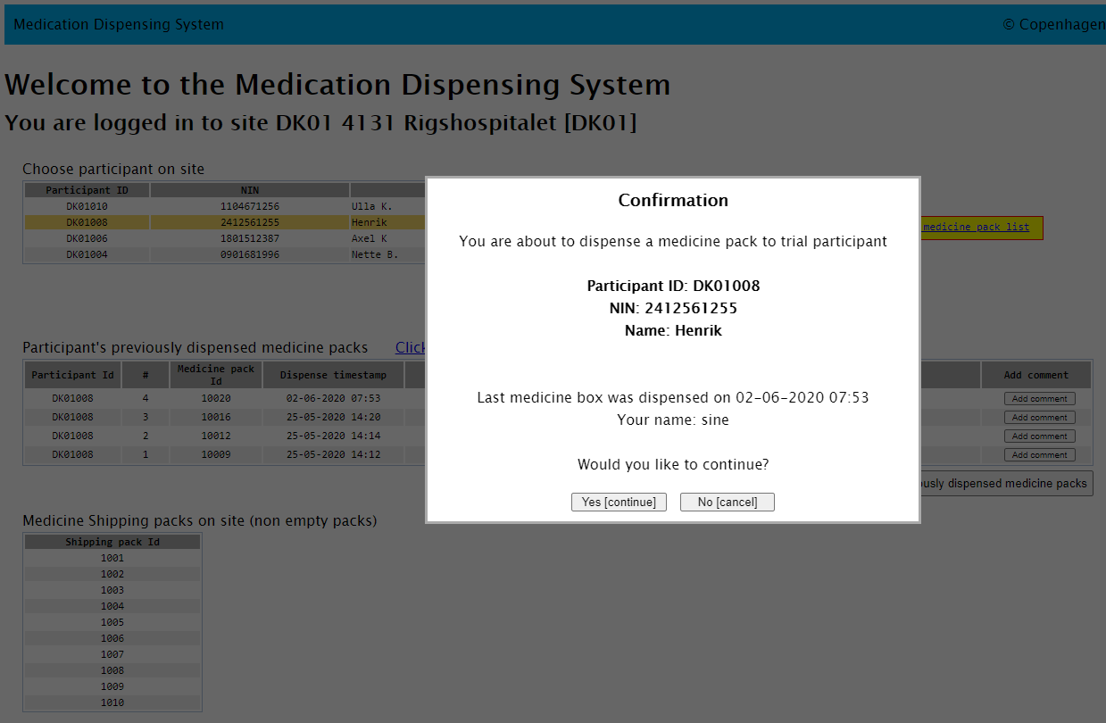

8) If you experience a problem with a vial, if the vial is broken or any other issues during dispensation or administration, please add a comment by clicking the ’Add comment’ in the right side.

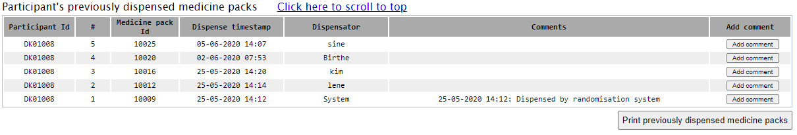

Patients will be randomised to receive either:
Active drug: furosemide 10 mg/mL
OR
Placebo: isotonic saline (sodium chloride 0,9%)

- The trial medication is dispensed as one vial at a time containing 50 ml of trial drug.
- After the randomisation procedure, the vial identification number will be sent to the Email-address of the person who performed the randomisation. All allocated vial identification numbers to a selected patient can be seen in the Medication Dispensing System.
- The identification numbers of the vials have to match the identification numbers provided for the patient in the Medication Dispensing System.
- If damage to the trial medication is suspected, do not use the trial medication. Allocate a new vial of trial medication to the patient in the Medication Dispensing System.
- The trial medication is administered as an initial injection of 0.5-4 ml according to the physicians discretion when the study starts followed by infusion of 0-4 mL/hour for the rest of the study.
- Dosing of the trial drug must be done accordingly to the GODIF algorithm. See SOP for trial medication section 9vi in site master file.

