Place in Site Master File #9
Instructions for the GODIF trial – eCRF
Please screen all adults meeting the inclusion criteria to assess their eligibility for inclusion in the GODIF trial. Re-assess the inclusion criteria during ICU stay in patients not meeting the criteria at ICU admission. A screening log is maintained to monitor patient recruitment at each site and will enable a description of the patient population from which eligible patients have been enrolled. All patients will be allocated a site-specific trial participant ID when initiating the screening procedure.
Questions and uncertainties may be answered by keeping the cursor on the [info] next to each question in the eCRF.
1) Go to www.cric.nu/godif
Click the eCRF link to ‘Screen, randomise and enter data’.
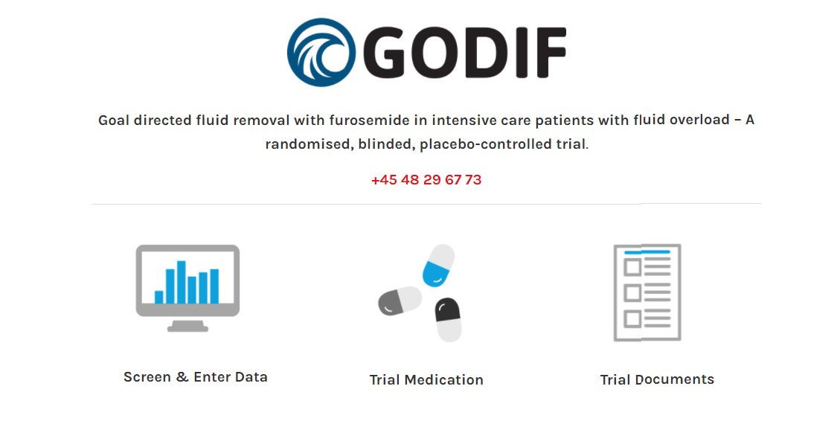

2) Login to the eCRF with your personal login.
If you have not received your login, please send an email to godif@cric.nu
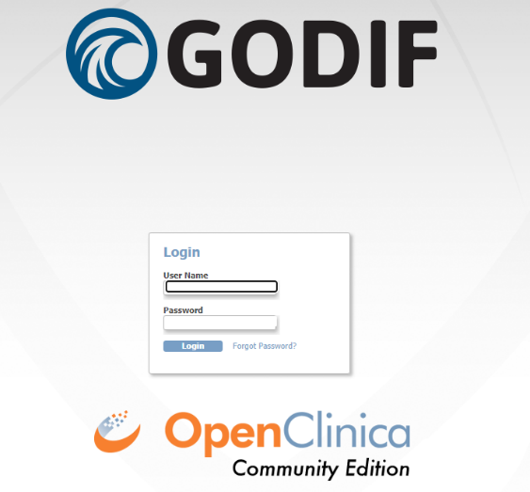

3) Click the ‘Go to patient screening’ button
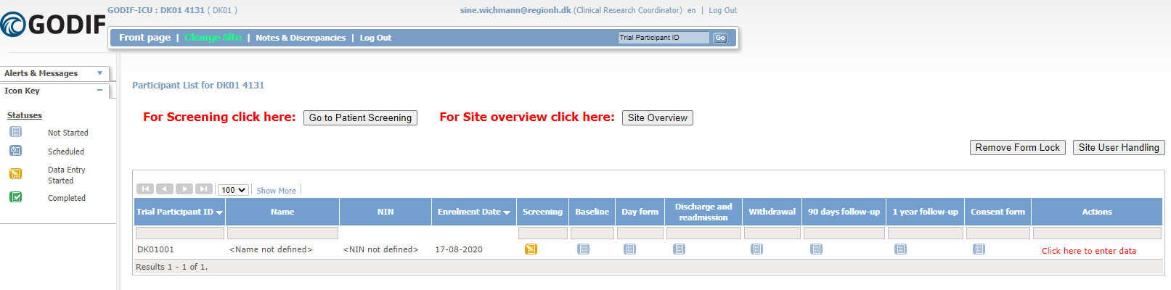

4) A national identification number (NIN) is needed to help identify the patient.
Danish sites:
Enter the CPR number for Danish participants. If a fictive CPR number has been constructed use the letter D as prefix to override the check of a valid CPR number. (e.g. D1010501234).
In all other countries, a NIN must be constructed
NIN is a unique number identifying the patient and will be checked by the system to make sure the same patient is not randomised more than once. In some countries, other rules will apply. Please consult your national investigator in case of uncertainties. The NIN consists of
- Date of birth (ddmmyy)
- A site identification (automatically generated)
- A serial number. Enter 01
If a warning appears, please check that the patient has not previously been enrolled. Two types of warnings are possible:
Red warning: The NIN is completely identical with a previously constructed NIN. If it is NOT the same patient, please change the seral number to 02.
Yellow warning: The NIN is partly identical to a previously constructed NIN. If the name of the patient does not appear on the list shown, pleas press ‘accept’ and continue.

5) Complete the screening form.
Note that fertile women < 50 years) must have a negative pregnancy test (urine or blood) before screening and that consent always has to be obtained according to national regulations.
When the form is complete, the text in the randomisation window will change to either green (eligible) or red (not eligible)

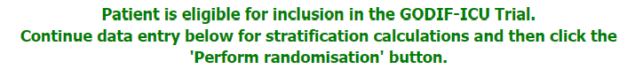

Fill in the boxes under the heading ‘Patient’. Which is needed to calculate stratifications (AKI and SMS-score) for this trial before randomisation is possible.
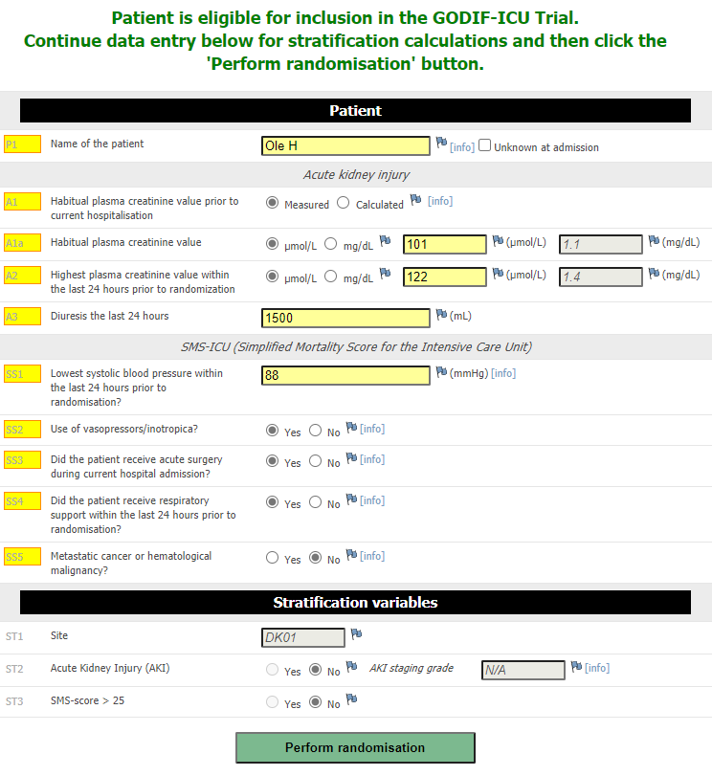
6) When the form is complete click ‘perform randomisation’ and a pack identification number will appear

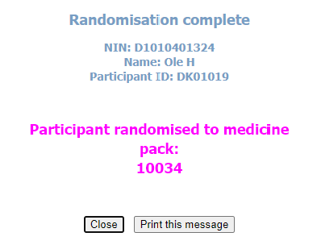
You can save/find the pack identification number by:
- Printing the message
- Opening the e-mail sent to the e-mail account used when logging in
- Opening the medication distribution system
- Opening the screening form. The pack identification will be visible just before the heading ‘Patient’ (on the middle of the page).

7) Prescribe the trial medication for the patient as a continuous infusion with 0-4 ml/hour in your medical chart/ICU chart/medicine program.

8) Administer the trial medication according to algorithm. See SOP for trial medication and algorithms for trial medication.

Further registration of data in the eCRF
After login you will see the participant list
(following screen shots taken from a demo version of the GODIF eCRF)

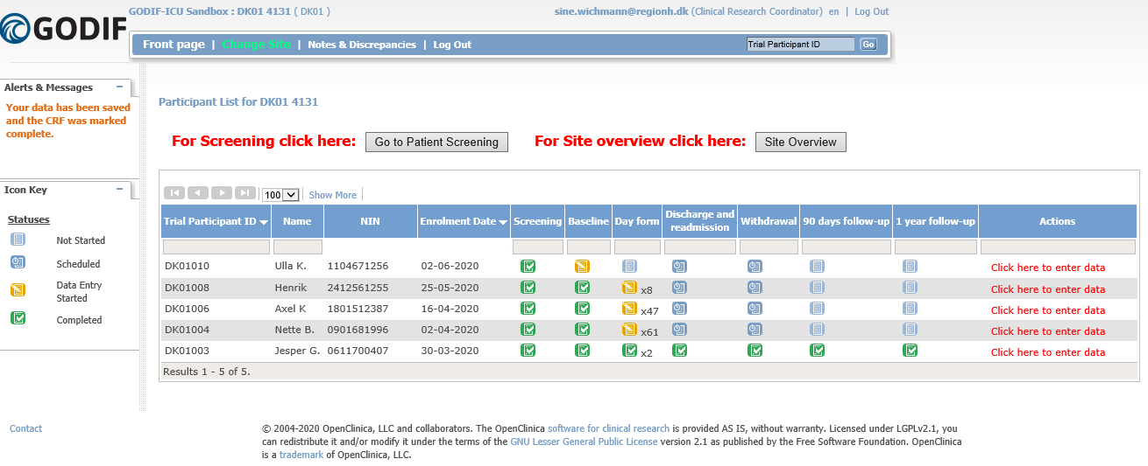
Each trial participant has one row. In the first three columns you will find:
- Trial participant ID – an automatically generated identifier number. Write this ID in your screening log and use it when communicating with the coordinating centre.
- Name of the participant (as written in the screening procedure)
- National identification number (NIN) (as described earlier)
- Enrolment date
The next columns show the different trial events (i.e. screening, baseline, day forms etc.)

New day forms will be generated daily (to a maximum of 90 days). The colour of the icon in the column with ‘Day form’ will switch to green when all generated day forms have been completed. When a new form is generated the icon will turn yellow again until all day forms have been completed. To see which day forms are incomplete, either click the ‘click here to enter data’ or go to the site overview (see next page).
From the front page (participant list) you can proceed to:
- Screening procedure (patient screening)
- Site overview
- Participant details (data entry)

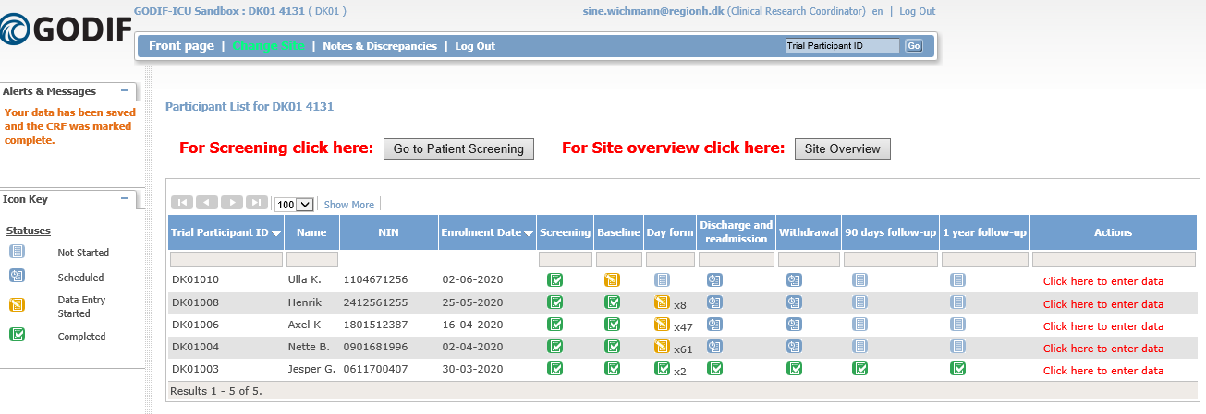

Site overview
In the upper right corner, you will find the ‘site overview’ button. Clicking this give you a quick overview of your enrolled patients
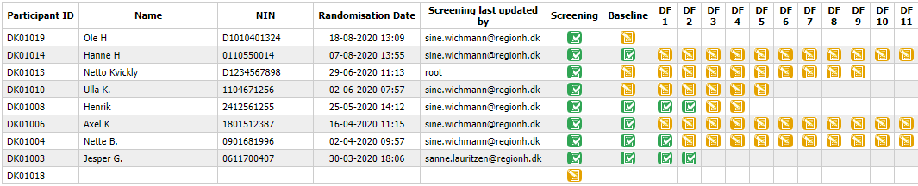
Hovering the will display the start and the end date pf the day form.
Click the to enter the incomplete form.
If icons are missing, the forms have not yet been generated.

Data entry – general information
After randomisation the following forms will be available:
- Baseline form
- Day form (1 for each day the participant is in the ICU to a maximum of 90 days)
- Discharge and readmission form (to be completed at discharge or death and in case of readmission)
- Withdrawal from (to be completed if the participant is withdrawn from the trial because of SAR/SUSAR, withdrawal from active therapy, withdrawal of consent, consent not obtained, clinical decision, or involuntary hospitalisation )
- 90-day follow-up form (becomes active 90 days after randomisation) if the participant dies in the ICU and the discharge form is completed, the follow-up form will automatically be completed.
- 1-year follow-up form (becomes active one year after randomisation)
- Consent form (all consents must be uploaded)
To enter the above listed forms, go to participant details be clicking ‘ Click here to enter data’ in the right side.

After entering the page of a participant, you can either
Enter or edit data. If you want to edit data in an already submitted form, click ‘ Administrative edit’
View data (read only)

In the forms
Questions and uncertainties may be answered by hovering the cursor over the [info] next to each question in the eCRF. A blue box will appear as shown on the screen shot below. This information should be read carefully and followed stringently.

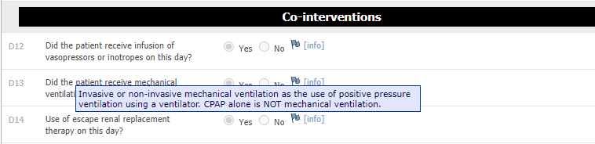

Date format is always dd-mm-yyyy and time format is 24 hours (hh:mm).
At the bottom of each form you will have the opportunity to:
- Submit form. This will only appear as an option once the form is complete
- Save. This will be an option when data has been entered
- Exit (no save). Use this if you entered the form and want to leave without entering data

The icons at the participant list and in the overview will turn green when a complete form has been submitted. If complete and only saved form, the icon will continue to be yellow .

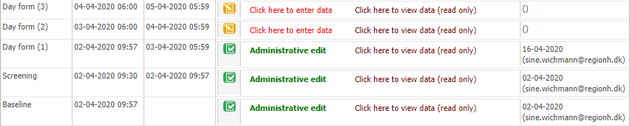

Specific forms in the eCRF
Baseline form
Please pay attention to the following:
- Hospital admission date and date of ICU admission: if the participant has been transferred from another ICU/hospital, please enter date and time of the first admission.
- When filling in the baseline form, all data should represent the condition at the time of randomisation, relevant periods before randomisation are specified within the questions or [info].

Day form
All days are defined as from 06:00 to 06:00, 24 h time, local time zone. The first day form will be available on the first morning after randomisation at 06:00 (i.e. the day after randomisation). The last day is from 06:00 until discharge or death. Hence, in most cases the first and last day will not be 24 hours. Hereafter a day form is generated once a day at 06:00 to a maximum of 90.
If a day from does not turn green when complete, please make sure the form has been submitted and not only saved.

Discharge and readmission
The discharge and readmission form is used to both discharge and readmit the participant (available several times). Hence, this form will only turn green if the participant is registered dead in the ICU. If a participant dies within the ICU, discharge the participant in the system by completing the discharge form. Entering the participant as discharged using this form will stop the generation of day forms and remove already generated day forms after the discharge date. Therefore, it may be advantageous to fill in the discharge form before active day forms.
If the patient is readmitted to the ICU, go to the discharge and readmission form again and click ‘add’. This will generate a new row. Please complete data and tame of readmission.
If an unnecessary row is generated, you must delete it by clicking ‘X’ in the right side.

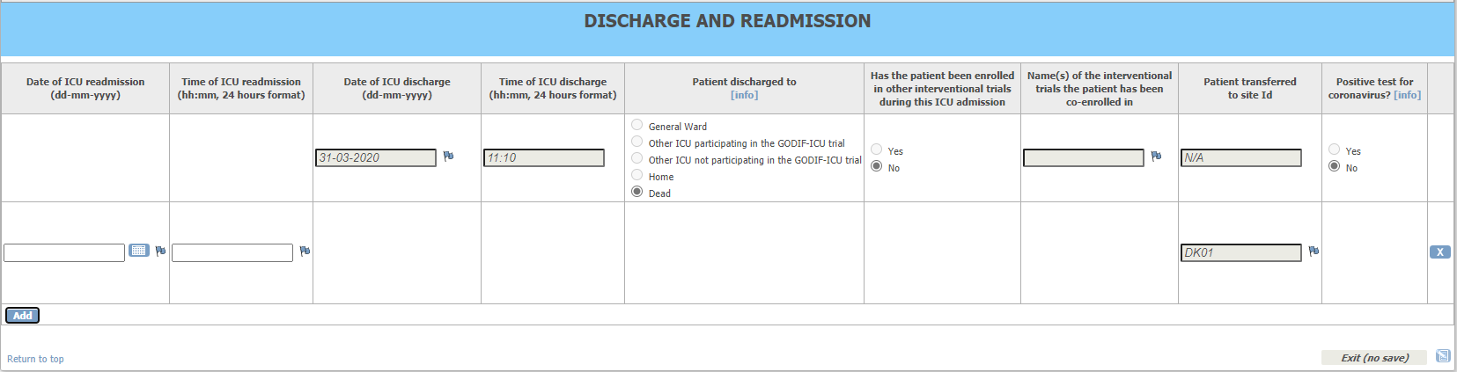

After filling in the readmission row of the discharge and readmission form, day forms will again be generated.

Patients transferred from/to another ICU
ICUs not participating in the GODIF trial:
If a patient is transferred to your ICU from an ICU not participating in GODIF trial, please screen the patient for inclusion in the GODIF trial throughout the visit.
If a patient is transferred from your ICU to a participating ICU, complete the discharge form and write the centre the participant will be transferred to. Please inform the receiving ICU that the patient is enrolled in the GODIF trial.

Withdrawal
The participant can be withdrawn from the trial for the following reasons:
- Clinical decision in conjunction with coordinating investigator
- Withdrawal from active therapy
- SAR/SUSAR
- Consent not given or withdrawn
- Patient is subject to involuntary hospitalisation
Please fill in the withdrawal form. If the participant accepts continued data registration, please obtain consent to this and write it in the medical chart.

Follow-up
90 days and one year after randomisation, the relevant follow-up forms will be activated respectively. Please fill in these forms when available.
If the participant dies within the ICU and this is registered in the discharge form, date of death will automatically be filled in and thus follow-up forms will appear green and will not have to be filled in.
If the participant is registered dead in the 90-day follow-up form, the one-year follow-up form will likewise be filled in automatically.

Consent form
Oral and written consent must be documented in this form and all the consent forms ( 1. trial guardian, 2. Trial guardian, next of kin, and patient) must be uploaded after it is signed. The consent form (the paper) from must also be kept in the site master file.

