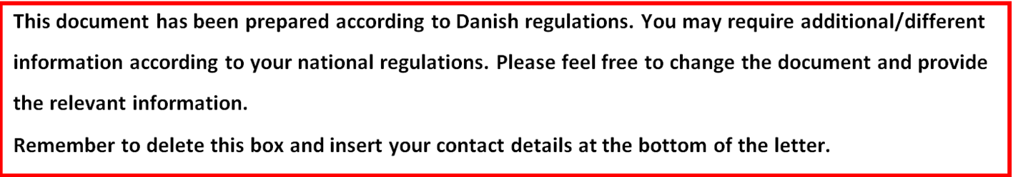

Information about participation in a scientific study of critically ill patients admitted to the intensive care unit

You have been seriously ill and were in need of immediate treatment in the intensive care unit. You have participated in a medical research project. Because of your condition, we were not able to inform you and ask you directly if you wanted to participate in the study.

Now that you are improving, we will ask you if you want to continue participating in the study. You must fully understand what the study is about, and why we are conducting it. We kindly ask you to read the information below carefully.

You will be offered a conversation with a person from the research group, where you will be given a more in depth understanding of the study and you can ask questions. You are welcome to bring a family member, a friend or an acquaintance to this conversation.

If you decide to continue your participation in the study, we will ask you to sign the attached consent form. Remember that you have the opportunity to consider your decision before signing.

It is voluntary to participate in the study. You may at any time and without giving a reason, withdraw your consent. Participation in the study will not have any influence on your treatment in general.

Background
For years it has been known that critically ill patients admitted to the intensive care unit are at risk of developing ulcers in the stomach due to stress caused by critical illness. Therefore, prophylaxis with drugs inhibiting the production of stomach acid, including proton pump inhibitors, has been the standard treatment. The drug is frequently used against acid reflux and heartburn in non-critically ill patients, but has never been assessed clinically among critically ill patients.

In recent years, it has been questioned whether the treatment should be given as standard treatment in the intensive care unit, because evidence has indicated that the treatment may increase the risk of pneumonia and gastrointestinal infections, and may even lead to increased mortality.

It is therefore unclear whether prophylaxis with acid-reducing drugs overall benefit or harm patients in the intensive care unit, and a study clarifying this is highly warranted.

Purpose of the study
The purpose of the study is to assess whether prophylactic treatment with proton pump inhibitor has a beneficial effect in patients admitted to the intensive care unit.

Status
You were admitted to the intensive care unit and treatment was immediately initiated because your condition required it. In relation to the scientific study you were randomly treated with either proton pump inhibitor or placebo (inactive saline) from the time you were admitted to the intensive care unit. Two doctors without involvement in the study approved your participation in the study before initiation treatment with the study drugs. Besides the study drugs, you have received normal treatment for your medical condition.
The study duration is from admission to the intensive care unit until discharge from the intensive care unit.

In addition to the physician in charge of the study, doctors and nurses working in the department contribute by practical implementation of the study.

Discontinuation of the trial
As a participant, you can at any time withdraw from the study without justification. Withdrawal will not affect your relationship with the doctors in the department or your treatment. You will continue to get the treatment that is standard for your medical condition.

Advantages of the experiment
You will not know for sure that participation in the study will be beneficial for you. However, by participating you can help ensuring that we get information telling us whether it is sound to give prophylactic treatment with proton pump inhibitors to critically ill patients. Thus, the collected data results in improved treatment of patients in the intensive care unit.

Disadvantages of the experiment
There are no disadvantages for you by participating in the study.

Side effects, risks and complications
Proton pump inhibitor is a very commonly used and well-known drug. The most frequently reported side effects are usually mild and transient. These include headache, abdominal pain and other conditions related to the gastrointestinal tract and mild allergic reactions.

Know serious side effects are very rare. These include dizziness, influence on the liver, kidneys and bone marrow and severe allergic reactions.

Treatment with saline has no side effects in the amounts administered in this study. When treated with saline you risk not getting a beneficial effect of proton pump inhibitor.

Patient Compensation
Damage caused by the study drugs is very unlikely in this study. However, if an injury occurs as a result of the study drugs you are covered by the public patient insurance. If you want to complain about anything related to your participation in this study, you can obtain instructions from the research group or from the patient counsellor in the region you live in.

Privacy and confidentiality
All information will be treated confidentially. When reporting results and when publishing the results of the study you will remain anonymous. The research group and the Good Clinical Practice monitoring group have access to your entire medical record to ensure that the study is carried out as described in the protocol. From your medical records we will use information about past medical history, surgical procedures during this hospitalization, blood test results, medication, treatment and events in the ICU. Anyone with access to the journal is subject to confidentiality.

Economy
The study is funded by Innovation Fund Denmark and is unrelated to the pharmaceutical industry. The fund has granted 36 million Danish kroners (4.83 million Euros) for the establishment of a research centre supporting research in intensive care medicine, including the SUP-ICU trial. The grant is subject to an external audit. The research group has no financial interest in the study.

Access to study results
When the study is completed we will determine survival and occurrence of side effects among participants. The results will be published in an international scientific journal and on the website of the study (www.sup-icu.com).

Contact
The duration of the study is estimated to be 2 years, and 3350 patients in Europe, Canada, Australia and New Zealand will participate.

We hope that you with this information feel sufficiently informed and able to make a decision about your potential participation. For further information please feel free to contact one of the investigators below.

Sincerely,

Local Principal Investigator:
NAME AND TITLE:
DEPARTMENT:
INSTITUTION:
WORKING ADDRESS:
PHONE:
EMAIL:

NAME AND TITLE:
DEPARTMENT:
INSTITUTION:
WORKING ADDRESS:
PHONE:
EMAIL:

