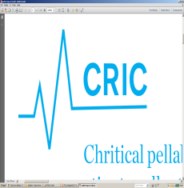

“Invitation to CRIC Scientific Steering Committee Meeting”
______________________________________________________________________________
Dear Scientific Steering Committee Member,
The next CRIC Scientific Steering Committee Meeting is to be held
Date: April 26, 2018
Meeting time: 1pm-3pm
Place: Forskningsenheden, 2rd floor, Tagensvej 22, 2100 Copenhagen N (same building as usual on the second floor)
Invited members: Bodil Steen Rasmussen (BSR), John A. Myburgh (JAM), Ville Pettilä (VP), Thorbjørn Grøfte (TG), Ingrid Egerod (IE), Jakob Kjellberg (JK), Jan Bonde (JB), Christian Gluud (CG), Morten H Bestle (MHB), Hans-Henrik Bülow (HHB), Robert Winding (RW), Theis Lange (TL), Helle L. Nibro (HN), Morten H. Møller (MHM), Jens Winther (WIN), Lone Musaeus Poulsen (LMP), Jørn Wetterslev (WET), Anders Perner (AP).
Invited non-members: Lars Winther, Innovationsfonden (LW), Morten Freundlich (MF), Maj-Brit Nørregaard Kjær, CRIC project manager (MNK)
Agenda
- Welcome (BSR) and presentation (all)
- Ongoing trials - HOT (BSR), AID (LMP) and CLASSIC (AP)
- Upcoming new research programs - GoDIFF (MHB)
- Follow-up of the outcome from the Strategic meeting about the future of CRIC (AP, MHM, LMP and JB)
- CRIC Office – homepage, budgets and accounts (MNK)
- Next meeting – suggestion October 25, 2019.

