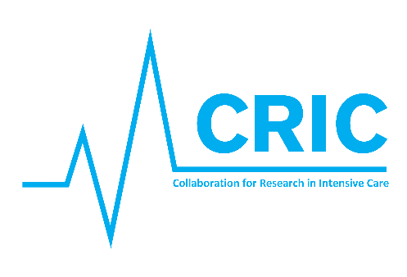
Agenda for the:
CRIC Steering Committee meeting Copenhagen 12th May 2020

At:
Dept. of Intensive Care, Copenhagen University Hospital / Rigshospitalet
Blegdamsvej 9, 2100 Copenhagen

4 pm – 7 pm, followed by dinner

4.00 - 4.30: Introduction (Bodil & Anders)
4.30 - 4.45: Who’s who in CRIC Steering Committee? Short round of introduction of SC members
4.45 – 5.30: CRIC – aims and future organizational structure – discussion
5.30 – 6.15: CRIC – new research project endorsement – how should it work?
6.15 – 6.45: Which supportive academic and administrative tasks should CRIC offer?
6.45 – 7.00: Conclusion (Bodil & Anders)

7.30 - : Dinner at local restaurant

