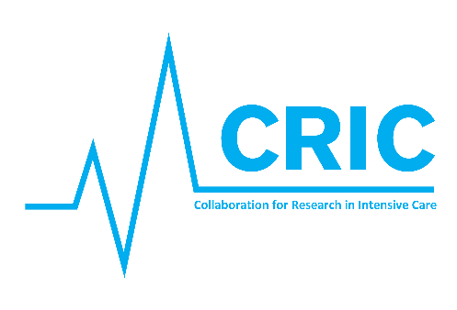

Agenda Collaboration for Research in Intensive Care (CRIC) meeting Copenhagen 13th May 2020

At:
Auditorium 2, Copenhagen University Hospital / Rigshospitalet, Copenhagen
Blegdamsvej 9, 2100 Copenhagen

13th May 8 – 11 am, followed by lunch

8.00 – 8.15: Welcome and introduction (Bodil Steen Rasmussen & Anders Perner)
8.15 – 8.30: Short round of introduction.
8.30 – 9.00: Brief summary from the Steering Committee meeting
9.00 – 9.20: Coffee
9.20 – 10.45: Discussion: CRIC II – the organization.
- How should the network be organized?
- Endorsement of new research projects
- What CRIC II may offer in terms of academic and administrative support

10.45 – 11:00: Conclusion (Bodil & Anders)

