Log on
Go to http://www.cric.nu/covid-steroid-2/. Here you will find all trial documents and a link to the electronic case report form (eCRF).
Click the ‘Screen, randomise, and enter data’.
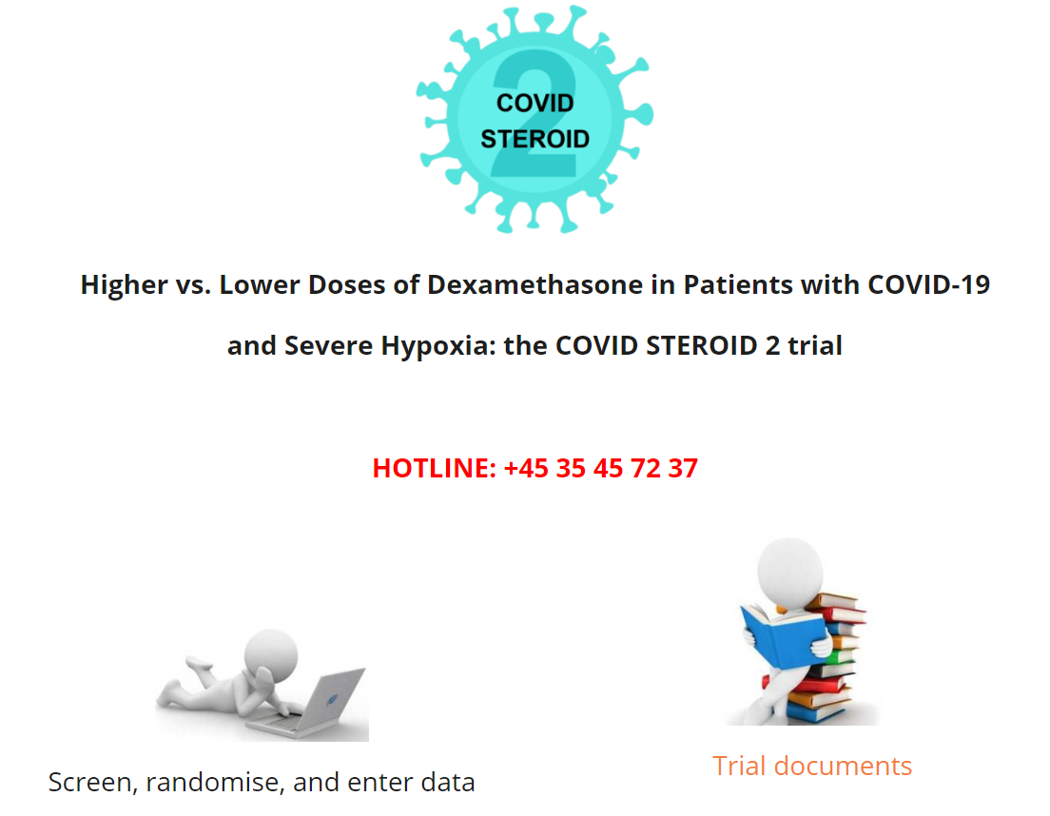

Enter username (e-mail) and password. The first time you log on, please use the password 12345678.
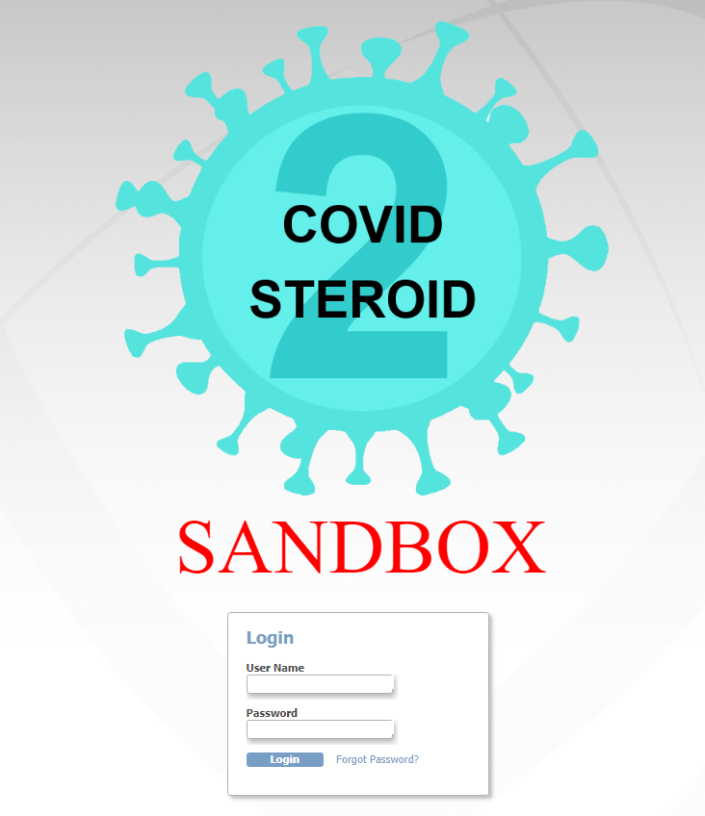
The screenshot is from a demo version of the eCRF
User access to the eCRF
Unblinded staff can screen, randomise, view allocation and enter data in the baseline form, administered trial medication form, consent form and withdrawal form. They can view but not edit data entered in dayforms, follow-up forms, and discharge and re-admission form.
Blinded staff can enter data in the baseline form, dayforms, follow up forms, discharge and re-admission form, consent form and withdrawal form. They can view but not edit data entered in the screening form and administered trial medication form. Blinded staff cannot view the allocation.
If you try to access forms you do not have access to, the system will lead you back to the front page automatically.

To view allocation for unblinded staff
Click ‘Allocation View’.

The allocation list will appear in a new window.
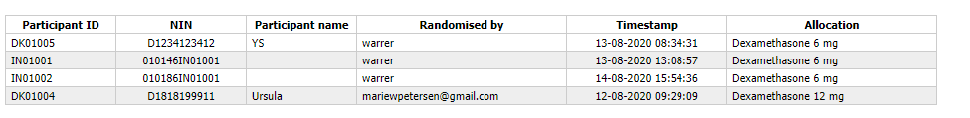

Overview of the eCRF
On the front page, you will see the participant list.
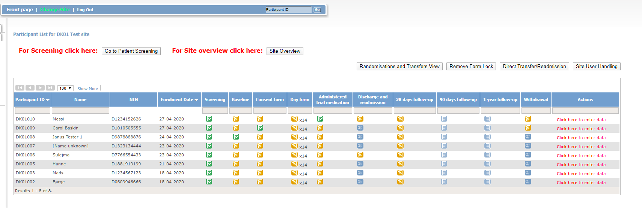The screenshot is from a demo version of the eCRF

The participant list contains participant ID, name, national identification number (NIN) and enrolment date. It also contains an overview of all forms for each participant. The colours of the icons indicate the status of the form:
Data entry not possible
Form scheduled, data entry possible if necessary (withdrawal, discharge)
Data entry possible/started but incomplete
Data entry completed

At the top of the webpage you can:
- Return to front page
- Change Site
- Log out
3
2
1

Change site
Here you can get an overview of all sites that you have access to. Please access the transfer site if a participant has been transferred from one site to another, and all forms have not been completed from the original site. Once all forms are completed, the participant will automatically appear at the new site.
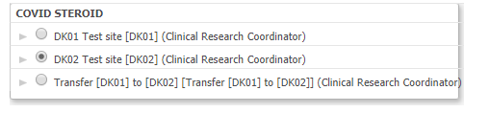

From the front page, you can access:
- Patient screening
- Site overview
- Data entry for each participant
2
1

3

Site overview
Here you can get an overview of all included and excluded patients.
- Scroll to select site
- List of included patients at site
- List of excluded patients at site
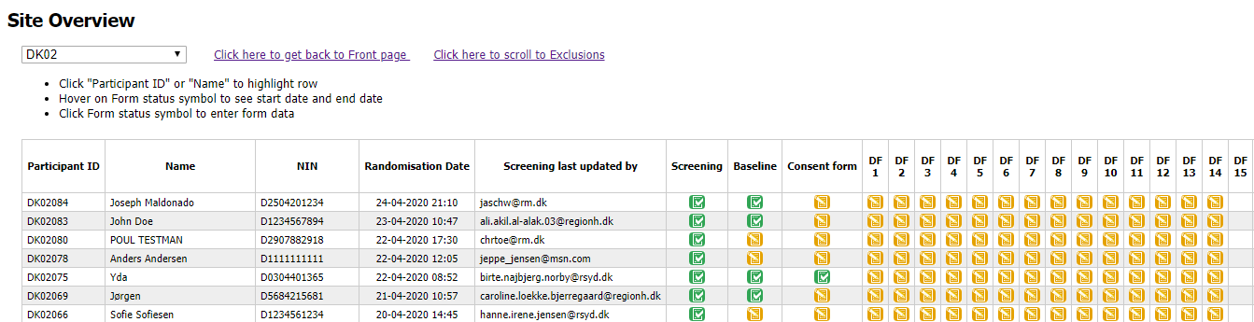
1
2

3

Data entry
To enter data, click on ‘Click here to enter data’ on the participant list.

To enter data for the first time, click ‘Click here to enter data’. To edit, click ‘Administrative edit’. To view data, click ‘Click here to view data’.

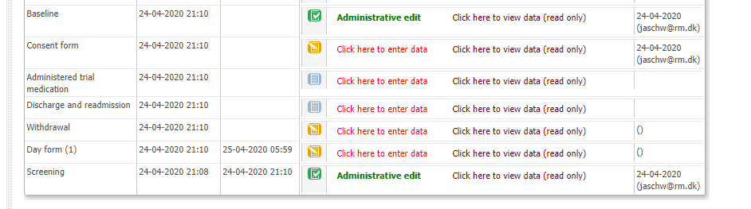

To get further information about each domain to be filled in the forms, hold the mouse over the [info] box.
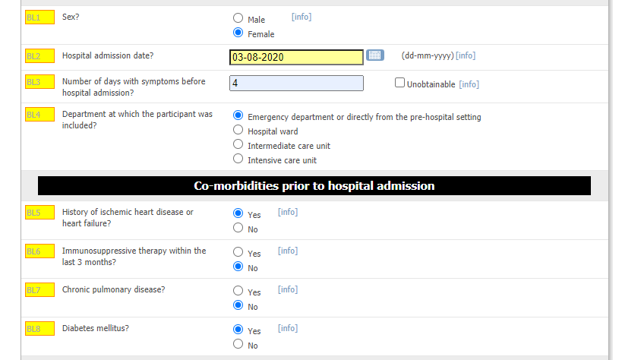

When the form has been completed, click ‘Submit form’. If data have been entered, but the form is not completed, click ‘Save’. If you do not want to save the entered data, click ‘Exit (no save)’.

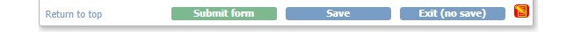
Please make sure that the form has been submitted (and not just saved) when you have completed data entry.

Specific forms in the eCRF
Screening form
National identification number:
For Danish sites, please type Danish National identification number:
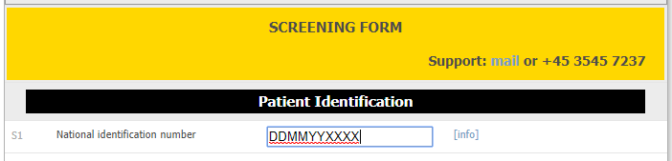

For international sites, please type in date of birth or year of birth according to local regulations.
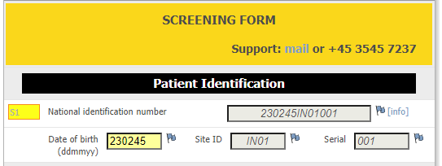

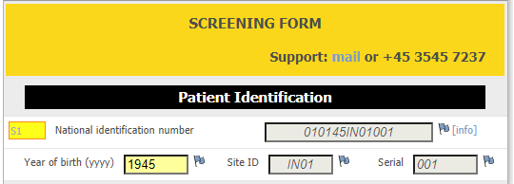

This will automictically generate a substitute national identification number in S1. Use this number to identify the patient on a separate list with further details about the patient according to local regulations.

Oxygen supplementation by open system: To calculate the oxygen supplementation through an open system, please use the provided converter (arrow) if a mixture of pure oxygen and atmospheric air is used.
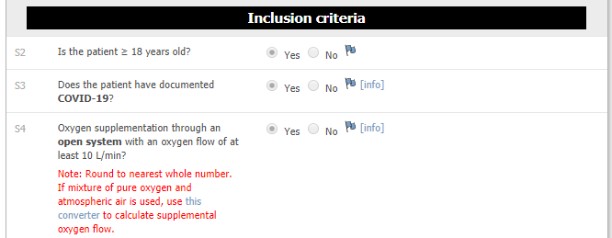

Baseline form
This is the most comprehensive form. Please note:
‘Hospital admission date’: Please enter the date of admission to the first hospital during current admission
‘Agents with potential anti-inflammatory action during current hospital admission?’: Enter yes, if given before first trial medication administration (also if this is after randomisation). Not including inhalation or topical drugs.
‘Use of any drug with potential antiviral activity during current hospital admission?’: Enter yes, if given before first trial medication administration (also if this is after randomisation). Not including topical drugs.

Administered trial medication (ATM) form
The number of ATM forms depend on the number of consecutive days with corticosteroid treatment before randomisation. The maximum number of ATM forms is 10 (for patients with no preceding corticosteroid treatment) and the minimum number is 6 (for patients with 4 consecutive days of corticosteroid treatment before randomisation). Patients who have received corticosteroids for 5 consecutive days or more will be excluded from the trial. The number of ATM forms is determined by subtracting the number of days with corticosteroids before randomisation from 10:
- 0 days of corticosteroid treatment before randomisation: 10 ATM forms
- 1 days of corticosteroid treatment before randomisation: 9 ATM forms
- 2 days of corticosteroid treatment before randomisation: 8 ATM forms
- 3 days of corticosteroid treatment before randomisation: 7 ATM forms
- 4 days of corticosteroid treatment before randomisation: 6 ATM forms
The number of ATMs form is generated automatically.

Discharge and readmission form
Discharge the participant when the participant is transferred to another hospital/ward, home or if the participant dies. If the participant is registered as dead, the generation of dayforms and follow-up forms will stop. Save and exit the form.
Re-enter and readmit the participant if the participant is transferred to another hospital/ward. This is done by clicking ‘Add’. Remember to apply site ID if the patient is transferred to another site participating in the COVID STEROID trial. Discharge and re-admission can be filled out as many times as needed within 90 days of randomisation or until death, but remember you must exit and re-enter the form every time you wish to add a new row.

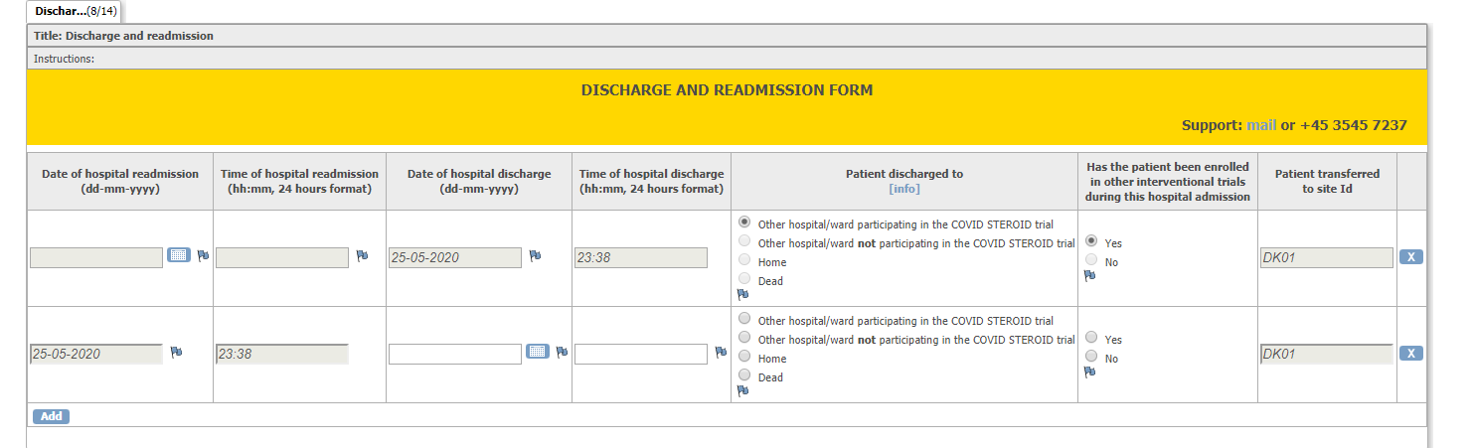
Remember to complete all forms when transferring a participant to another trial site. The participant will appear in the transfer site until this is done. Remember to inform the receiving site about the transferal.

Withdrawal
The participant can be withdrawn for the following reasons:
- Clinical decision in conjunction with coordinating investigator
- Withdrawal from active therapy
- SAR/SUSAR
- Consent not given or withdrawn
- Patient is subject to compulsory hospitalisation
Remember to fill out the withdrawal form if the participant is withdrawn.
Data registration will continue if the participant is withdrawn due to clinical decision in conjunction with coordinating investigator, withdrawal from active therapy, SAR/SUSAR or if the participant is subject to compulsory hospitalisation.
If consent is not given or withdrawn, remember to ask for permission to continue data registration.

Dayforms
Dayforms will be generated automatically the first 14 days after randomisation. Registration of major protocol violations (use of open-label corticosteroids) will be registered up to 10 days after randomisation (the same period as trial medication is administered).
If the participant dies and is discharged to ‘Dead’, the generation of dayforms will stop automatically.

Follow-up forms
Follow-up forms will be generated automatically 28 days, 90 days and 180 days after randomisation.
If the participant dies and is discharged to ‘Dead’, the remaining follow-up forms will be filled out automatically.

Consent form
Co-enrolment may be noted in the consent form.
Click ‘Oral and written trial information given’, when the trial guardian/next of kin/participant have been informed orally and have received written information about the trial.
Remember to upload the consent form electronically when this has been signed by the trial guardian/next of kin/participant.
