Place in Site Master File # 6b
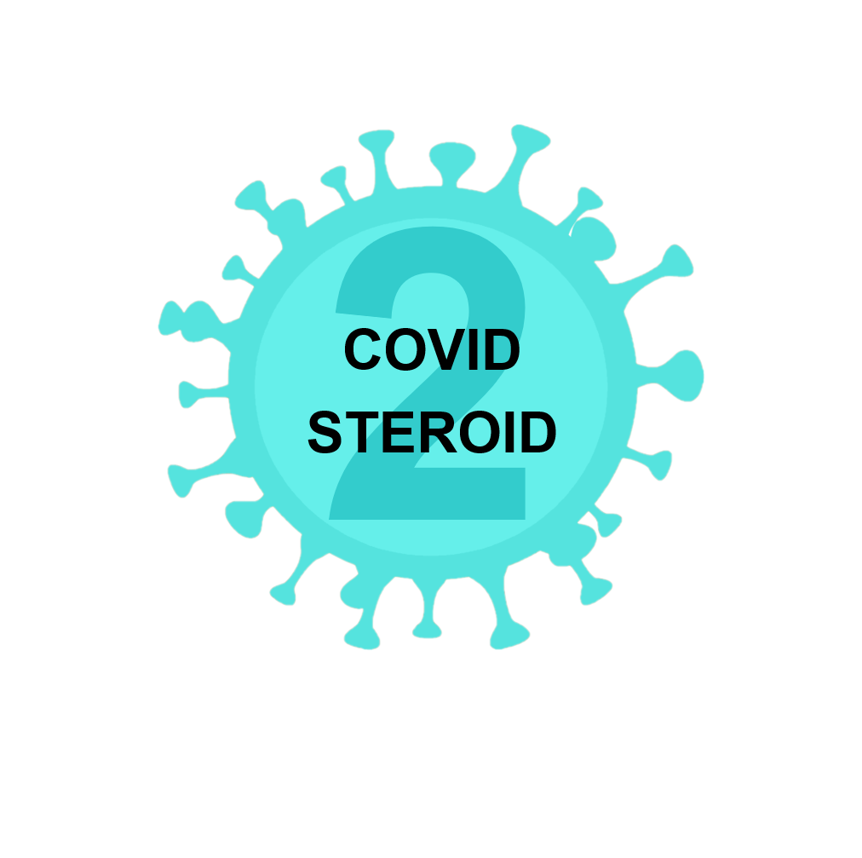

COVID STEROID 2 Case money form

Thank you very much for recruiting patients in the COVID STEROID 2 trial

Number of patients eligible for case money and corresponding pay-out

The e-CRF has per [insert date] revealed that in [insert quarter] of [insert year] your site [insert site name] is eligible for case-money for the following number of patients with corresponding pay-out cut at a finalised 90-days follow-up:

- Included patients with adequate 90-days follow-up without transferal to another site (recruiting site will perform 180 days follow-up) (400 Euro/participant)
XXX = YYY Euro

- Included patients with adequate 90-days follow-up with transferal to a hospital/ward not participating in the COVID STEROID 2 trial (recruiting site will perform 180 days follow-up) (400 Euro/participant)
XXX =YYY Euro

- Included patients with transferal to another COVID STEROID site (recruiting site will perform 180 days follow-up) (300 Euro/participant)
XXX = YYY Euro

- Transferred patients (1st transferal) from another site for continued intervention, consent procedures and data entry in the e-CRF up to 90-days follow-up or until transferal to another site (100 Euro/participant)
XXX = YYY Euro

Total = YYY Euro

Please prepare an invoice covering the case money and forward it by e-mail to contact@cric.nu.
We foresee that your financial department may need the following information: VAT no. 29765790.

How we count patients
We use information from the e-CRF to count patients in the steps outlined which at any time will be those patients not accounted for since the last counting. We will count patients once a quarter.

Contact CRIC
If you have any concerns regarding case money pay-out, please feel free to contact CRIC by sending an e-mail to contact@cric.nu or by phone +45 3545 0552.

